Assignment 2
Uniform and Informed Search Algorithm

Name: Tanishka Bhor
PRN: 202401040132
Batch : A2
Roll no: 34

Disaster Drone Rescue Route Finder Using Search Algorithms

Aim
To design and implement a Disaster Drone Rescue Route Finder that uses uninformed and informed search algorithms to find an effective route for an autonomous drone to reach a person trapped in a disaster-affected area while considering different paths and travel costs.

Objectives
- To represent a disaster-affected area as a weighted graph consisting of locations and possible drone paths.
- To implement uninformed search algorithms for finding possible routes from the drone base to the victim.
- To implement informed search algorithms using heuristic information to guide the drone toward the destination.
- To compare the performance of different search algorithms based on path, cost, and search behavior.
- To identify a suitable route for the drone in an emergency rescue situation.
- To understand the practical application of Artificial Intelligence search techniques in disaster management.

3. Application Details
Consider a disaster-affected area where people are trapped because of situations such as floods, earthquakes, landslides, or collapsed buildings.
A rescue drone is deployed from a Drone Base to locate and reach a Trapped Person (Victim). The disaster area contains several zones connected by possible flight paths. Some paths may be longer or have a higher travel cost than others.
The drone needs to find a suitable route from the Drone Base to the Victim using different Artificial Intelligence search algorithms.
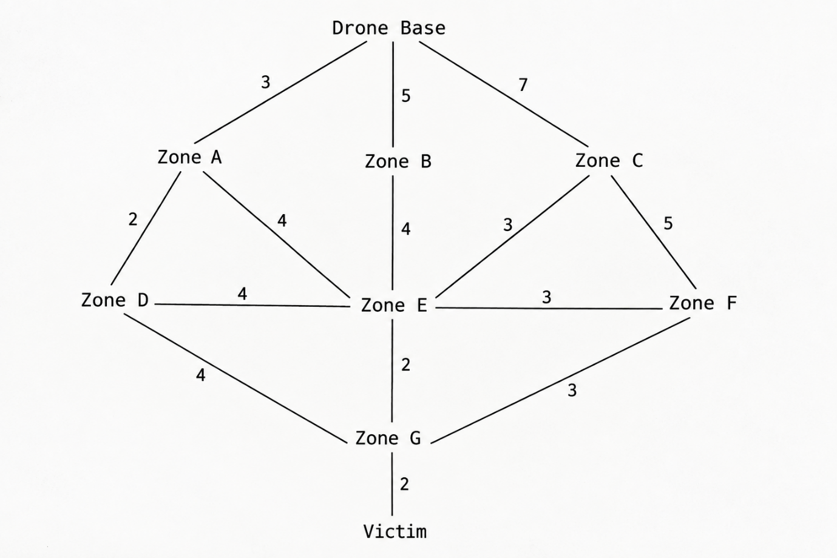

Each connection represents a possible drone flight path, and the number represents its distance/cost.

Example Route
One possible route is:

Drone Base → Zone A → Zone D → Zone G → Victim

Its total cost is:

- Drone Base → Zone A = 3 km
- Zone A → Zone D = 2 km
- Zone D → Zone G = 4 km
- Zone G → Victim = 2 km
Therefore:
Total Cost = 3 + 2 + 4 + 2 = 11 km
The program stores these disaster zones and their distances in a weighted graph.

Application Working
The system takes:
Starting Location: Drone Base
Destination: Victim
The user can select different search algorithms. The selected algorithm searches the disaster-zone graph and produces a route.
The program can display:
- Discovered route
- Total route cost/distance
- Visited nodes
- Search behavior
- Comparison between algorithms
For informed algorithms such as Greedy Best-First Search and A*, heuristic values representing the estimated distance from each zone to the Victim are used.
The same application structure in the reference practical uses a weighted graph, heuristic values, route cost, visited nodes, and algorithm comparison; these elements are retained here while changing the application to drone rescue.

4. Algorithms Used
A. Uninformed Search Algorithms
These algorithms do not use heuristic information. They search the disaster-area graph based on its structure.

1. Breadth First Search (BFS)
Breadth First Search (BFS) explores the nodes level by level.
In the Disaster Drone Rescue problem, BFS starts from the Drone Base and explores nearby locations first before moving to locations farther away.
Principle:
- Uses a Queue
- Follows FIFO (First In First Out)
- Explores level by level
Data Structure: Queue
Basic Algorithm
BFS(Start, Goal)
- Insert the Start node into the Queue.
- Mark the Start node as visited.
- While the Queue is not empty:
  - Remove a node from the front of the Queue.
  - Check if the node is the Goal.
  - If it is the Goal, return the path.
  - Add all unvisited neighboring nodes to the Queue.
- If the Queue becomes empty, return failure.
Example:
If the drone starts at:
Drone Base → Zone A → Zone C → Zone F → Victim
BFS explores the disaster zones level by level until it reaches the Victim.
The implementation can use Python's deque as the queue.

2. Depth First Search (DFS)
Depth First Search (DFS) explores one path as deeply as possible before backtracking and exploring another path.
In the drone rescue problem, DFS may follow one disaster-zone route deeply before returning and trying another route.
Principle:
- Uses a Stack
- Follows LIFO (Last In First Out)
- Goes deep before exploring other branches
Data Structure: Stack
- Basic Algorithm
DFS(Start, Goal)
- Insert the Start node into the Stack.
- While the Stack is not empty:
  - Remove the top node.
  - Mark it as visited.
  - Check if the node is the Goal.
  - If it is the Goal, return the path.
  - Push unvisited neighboring nodes into the Stack.
- If the Stack becomes empty, return failure.
DFS can be implemented using a Python list as a stack.

3. Depth Limited Search (DLS)
Depth Limited Search (DLS) is a modified version of DFS in which a maximum depth limit is specified.
For example:
Depth Limit = 3
The drone cannot search beyond depth 3.
Principle:
DLS = DFS + Depth Limit
Basic Algorithm
DLS(Start, Goal, Limit)
- Start from the initial node.
- Search using DFS.
- Keep track of the current depth.
- If the Goal is found, return the path.
- If the current depth reaches the specified Limit, stop searching that branch.
- Continue searching other branches within the limit.
The depth limit can be provided dynamically.
Example:
If:
Drone Base → Zone A → Zone C → Zone F → Victim
requires depth 4, then a depth limit of 2 or 3 will not be sufficient to reach the Victim.
This is the same DLS principle used in the reference practical.

4. Iterative Deepening Search (IDS)
Iterative Deepening Search (IDS) repeatedly performs DLS with an increasing depth limit.
The search proceeds as:
DLS depth 0
↓
DLS depth 1
↓
DLS depth 2
↓
DLS depth 3
↓
DLS depth 4
↓
...
Basic Algorithm
IDS(Start, Goal)
- Set depth = 0.
- Perform DLS(Start, Goal, depth).
- If the Goal is found, return the path.
- Increase the depth by 1.
- Repeat until the Goal is found.
For the drone rescue problem, IDS gradually increases the search depth until it reaches the trapped person.
The reference practical uses the same approach of repeatedly calling DLS until the destination is found.

5. Bidirectional Search
Bidirectional Search searches simultaneously from the Start and the Goal.
For the Disaster Drone Rescue problem:
Drone Base → → → →
↓
Meeting
↑
Victim ← ← ← ← ←
There are two searches:
- Forward Search: Drone Base → ...
- Backward Search: Victim → ...
The searches continue until they meet.

Basic Algorithm
- Start one BFS from the Drone Base.
- Start another BFS from the Victim.
- Expand both searches.
- Check whether their visited nodes intersect.
- When the searches meet, construct the complete route.
The reference implementation similarly maintains separate forward and backward queues and parent relationships.

B. Informed Search Algorithms
These algorithms use heuristic information to guide the search toward the destination.
For the drone rescue problem, the heuristic can represent the estimated distance from the current disaster zone to the Victim.

6. Greedy Best-First Search
Greedy Best-First Search chooses the node that appears to be closest to the destination according to the heuristic value.
Formula
f(n) = h(n)

Where:
- h(n) = estimated cost from the current node to the Goal
- f(n) = priority of the node
For example:
Zone A → Zone C
h(C) = 4

Zone A → Zone D
h(D) = 7
The algorithm selects Zone C because it has the smaller heuristic value.

Basic Algorithm
- Put the Start node into a Priority Queue.
- Calculate the heuristic value h(n).
- Select the node with the smallest h(n).
- Expand that node.
- Add its neighboring nodes.
- Repeat until the Goal is reached.
The reference implementation uses heapq as the priority queue.

7. A* Search
A* Search combines:
- Actual cost already travelled
- Estimated cost remaining to the destination
Formula
f(n) = g(n) + h(n)
Where:
- g(n) = actual cost from Start to current node
- h(n) = estimated cost from current node to Goal
- f(n) = total estimated cost
Example
Suppose:
Drone Base → Zone A
g(A) = 3 km
h(A) = 6 km
Then:
f(A) = g(A) + h(A)
f(A) = 3 + 6 = 9
The node with the smallest f(n) is selected.

Basic Algorithm
A(Start, Goal)*
- Put the Start node into the Priority Queue.
- Set g(Start) = 0.
- Calculate f(n) = g(n) + h(n).
- Select the node with the smallest f(n).
- Expand that node.
- Update the costs of neighboring nodes.
- Repeat until the Goal is reached.
A* therefore considers both the route already travelled and the estimated remaining distance.

C. Local Search Algorithms

8. Hill Climbing Algorithm
Hill Climbing is a local search algorithm used for solving optimization problems.
It starts with an initial solution and repeatedly moves toward a better neighboring solution.
The idea is similar to climbing a hill: at every step, the algorithm tries to move to a better position until no better neighboring solution is available.

In Disaster Drone Rescue
The drone starts with an initial route.
For example:
Drone Base → Zone A → Zone D → Zone F → Victim

The algorithm checks neighboring route possibilities and attempts to improve the route based on factors such as:
- Route distance
- Travel cost
- Estimated remaining distance
If a better neighboring route is found, the drone moves to that solution.
If no better neighboring solution is available, the algorithm stops.

9. Genetic Algorithm
A Genetic Algorithm (GA) is an optimization technique inspired by the concept of natural selection and evolution.
Instead of searching through only one route, it maintains a population of possible routes.
Main Steps
- Generate Initial Population
Create several possible drone routes.
- Calculate Fitness
Evaluate each route based on its quality, such as total distance or rescue cost.
- Selection
Select better routes for reproduction.
- Crossover
Combine parts of two selected routes to generate new routes.
- Mutation
Make small changes to some routes to introduce variation.
- Repeat
Continue the process for several generations.
- Best Route
The route with the best fitness is selected.
Example
Possible routes:
Route 1: Base → A → C → F → Victim
Route 2: Base → B → E → F → Victim
Route 3: Base → A → D → E → Victim
The algorithm evaluates these routes and evolves better solutions over generations.

D. Constraint-Based Search

10. CSP – Constraint Satisfaction Problem
A Constraint Satisfaction Problem (CSP) represents a problem using:
- Variables
- Domains
- Constraints
For the Disaster Drone Rescue problem:
Variables
The positions visited by the drone can be represented as:
X0, X1, X2, X3, X4
For example:
X0 = Drone Base
X1 = Zone A
X2 = Zone C
X3 = Zone F
X4 = Victim
Domains
Each variable can contain a possible connected disaster-zone location.
For example:
X1 = {Zone A, Zone B, Zone C}
depending on which locations are directly connected to the Drone Base.
Constraints
The route must satisfy certain conditions:
- The route must start at Drone Base.
- The route must end at Victim.
- Two consecutive locations must be directly connected.
- A location should not be visited more than once.
- The route must contain a finite number of locations.
- Backtracking is used to search through possible assignments.
These constraints are adapted directly from the reference practical's route-CSP structure.

11. Backtracking
Backtracking is a systematic method of solving a CSP by assigning values one at a time.
If an assignment violates a constraint, the algorithm rejects that choice and goes back to try another possibility.

Basic Working
Suppose the drone has:

Drone Base
↓
Zone A
↓
Zone C
↓
Zone F
↓
Victim
The algorithm:
- Assigns X0 = Drone Base.
- Selects a connected location for X1.
- Checks whether the assignment satisfies the constraints.
- Assigns the next location.
- Continues until Victim is reached.
- If a selected location violates a constraint, reject it.
- Go back to the previous assignment.
- Try another possible location.
- Continue until a valid route is found.
Example
X0 = Drone Base
X1 = Zone A
X2 = Zone C
X3 = Zone F
X4 = Victim
This gives:

Drone Base → Zone A → Zone C → Zone F → Victim

If the algorithm encounters a route such as:
Drone Base → Zone A → Zone C → Zone A
then Zone A is already present in the route, so that assignment is rejected and the algorithm backtracks to try another location.
The reference implementation similarly rejects repeated locations, tracks the current route and cost, and backtracks after exploring each assignment.

CSP + Backtracking Flow
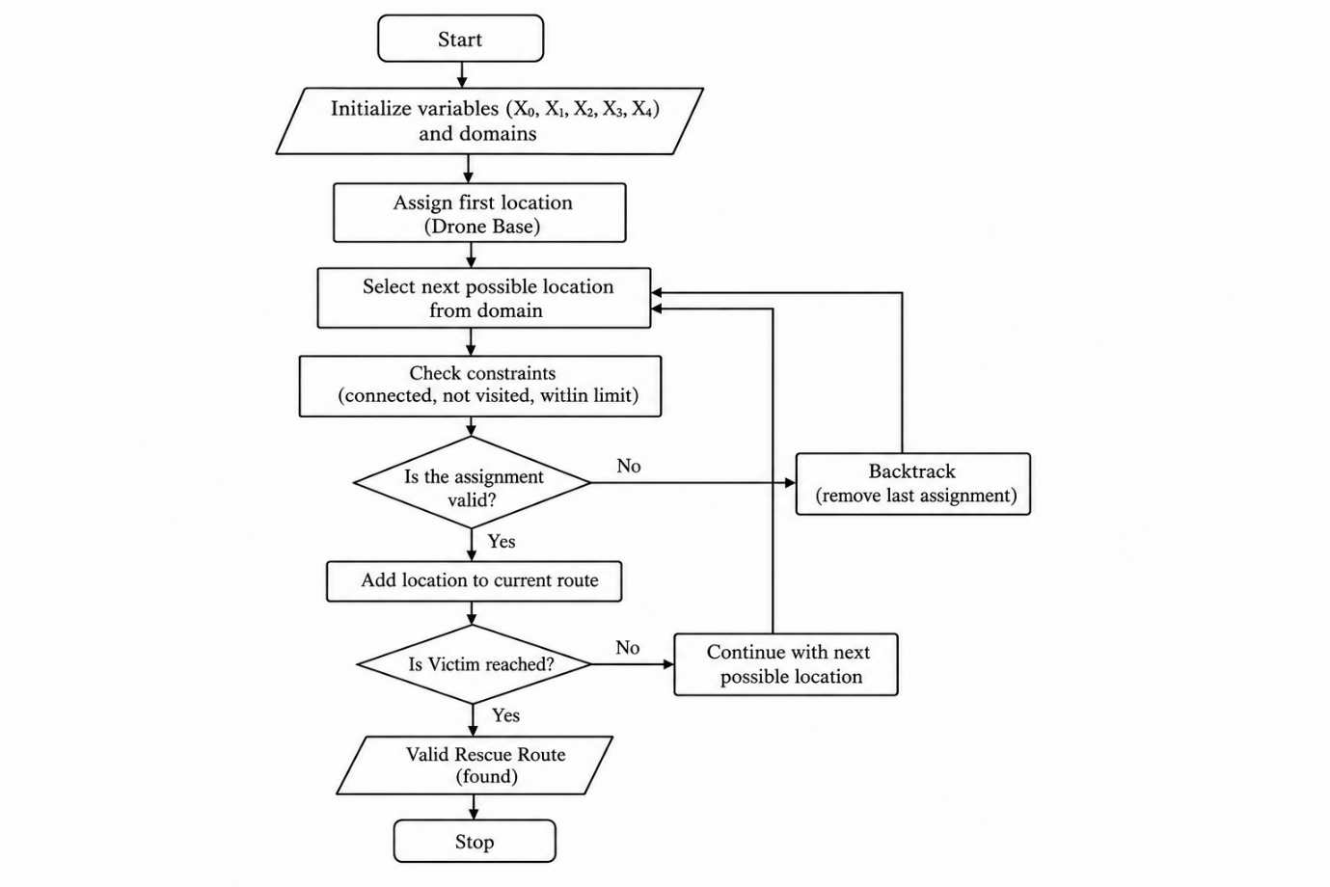

8. Observation

DFS
DFS explored one branch deeply before moving to another branch. Its visited-node sequence was different from BFS because of its depth-first exploration behavior.

DLS
The result of DLS depended on the selected depth limit. A smaller depth limit could prevent the search from reaching the Victim, while a sufficient limit allowed the route to be found.

IDS
IDS gradually increased the depth limit and continued searching until a route to the Victim was found.

Bidirectional Search
The search progressed from both the Drone Base and Victim sides. The two searches continued until a common zone was reached.

Greedy Best-First Search
Greedy Best-First Search selected zones according to their estimated distance from the Victim. Its behavior depended on the heuristic values assigned to the zones.

A* Search
A* considered both the cost already travelled and the estimated remaining cost. It therefore evaluated routes using f(n) = g(n) + h(n).

Hill Climbing
Hill Climbing attempted to improve the current rescue route by selecting a neighboring route with a lower total distance. Its result depended on the initial route.

Genetic Algorithm
The Genetic Algorithm generated multiple candidate rescue routes and improved them through selection, crossover, and mutation over successive generations.

CSP and Backtracking
The CSP approach checked whether the selected zones satisfied the defined route constraints. When an invalid assignment was encountered, Backtracking removed the previous assignment and tried another possible zone.

Algorithm | Category | Route/Behavior | Cost
BFS | Uninformed | Depends on level and neighbor order | Depends on output
DFS | Uninformed | Deep branch before backtracking | Depends on output
DLS | Uninformed | Depends on depth limit | Depends on output
IDS | Uninformed | Increasing depth limits | Depends on output
Bidirectional | Uninformed | Searches from both ends | Depends on output
Greedy Best-First | Informed | Uses estimated remaining cost | Depends on heuristic
A* | Informed | Uses actual + estimated cost | Expected low-cost route
Hill Climbing | Local | Improves neighboring routes | Depends on initial route
Genetic Algorithm | Local/Optimization | Evolves population of routes | Depends on generations
CSP + Backtracking | Constraint | Finds routes satisfying constraints | Depends on search

- Result

The Disaster Drone Rescue Route Finder was successfully designed using Artificial Intelligence search techniques.
The application represents a disaster-affected area as a weighted graph, where the nodes represent the Drone Base, disaster zones, and Victim, while the edges represent possible drone paths with associated travel costs.
The application implements different search techniques including:
- Breadth First Search
- Depth First Search
- Depth Limited Search
- Iterative Deepening Search
- Bidirectional Search
- Greedy Best-First Search
- A* Search
- Hill Climbing
- Genetic Algorithm
- CSP with Backtracking
The system can find possible routes from the Drone Base to the Victim, calculate their route costs, and compare the behavior of different search algorithms.
For the given disaster-zone network, a low-cost route is:
Drone Base → Zone A → Zone D → Zone G → Victim
with a total distance of:
11 km
The application demonstrates how different AI search techniques can be applied to an emergency drone-rescue routing problem.

- Conclusion

This practical demonstrates the application of Artificial Intelligence search algorithms to a real-life disaster management problem.
The Disaster Drone Rescue Route Finder models the disaster-affected area as a weighted graph and searches for a route from the Drone Base to the Victim.
Uninformed algorithms such as BFS, DFS, DLS, IDS, and Bidirectional Search explore the graph without using heuristic information. In contrast, informed algorithms such as Greedy Best-First Search and A* use heuristic information to guide the search toward the destination.
A* considers both the actual cost already travelled and the estimated remaining cost using:
f(n) = g(n) + h(n).
Hill Climbing and Genetic Algorithm demonstrate how local and optimization-based techniques can be applied to improve possible rescue routes. CSP and Backtracking demonstrate how constraints such as connected locations, no repeated zones, starting at the Drone Base, and ending at the Victim can be incorporated into route finding.
Overall, the practical shows that the choice of search algorithm affects the search behavior, number of nodes explored, route obtained, and computational efficiency. It demonstrates how AI-based search can be used for route planning in disaster-response and autonomous drone rescue applications.
Implementation Link: https://colab.research.google.com/drive/1gz0yWiSnUYmmPnitts47afCr0dQMUIJi?usp=sharing

Drive Link:
https://drive.google.com/file/d/13ytgYPCQKNmMrxW12tX2NtSSmN1n4OLN/view?usp=drive_link
